**CP Club 365Days Challenge**

**Programming language – C++**

**Problem Statement**

[https://practice.geeksforgeeks.org/problems/twice-counter4236/1?page=1&difficulty[]=0&category[]=Strings&sortBy=accuracy](https://practice.geeksforgeeks.org/problems/twice-counter4236/1?page=1&difficulty%5b%5d=0&category%5b%5d=Strings&sortBy=accuracy)

**Your Code**:

// 0x63Day of 0x365Days challenge

// VEDANT BHARAD

// 19-12-2022

//{ Driver Code Starts

#include <bits/stdc++.h>

using namespace std;

// } Driver Code Ends

class Solution

{

    public:

        int countWords(string list[], int n)

        {

            //code here.

            sort(list, list + n);

            int count = 0,loop1=0,loop2;

            while (loop1<n)

            {

                string temp= list[loop1];

                int loop2=loop1,con=0;

                while(list[loop2]==temp)

                {

                    con++;

                    loop2++;

                }

                if(con==2) count++;

                loop1=loop2;

            }

            return count;

        }

};

//{ Driver Code Starts.

int main()

{

    int t;

    cin>>t;

    while(t--)

    {

        int n;

        cin>>n;

        string list[n];

        for(int i=0;i<n;i++)

            cin>>list[i];

        Solution ob;

        cout <<ob.countWords(list, n)<<endl;

    }

    return 0;

}

// } Driver Code Ends

**Output (Screen Shot)**:

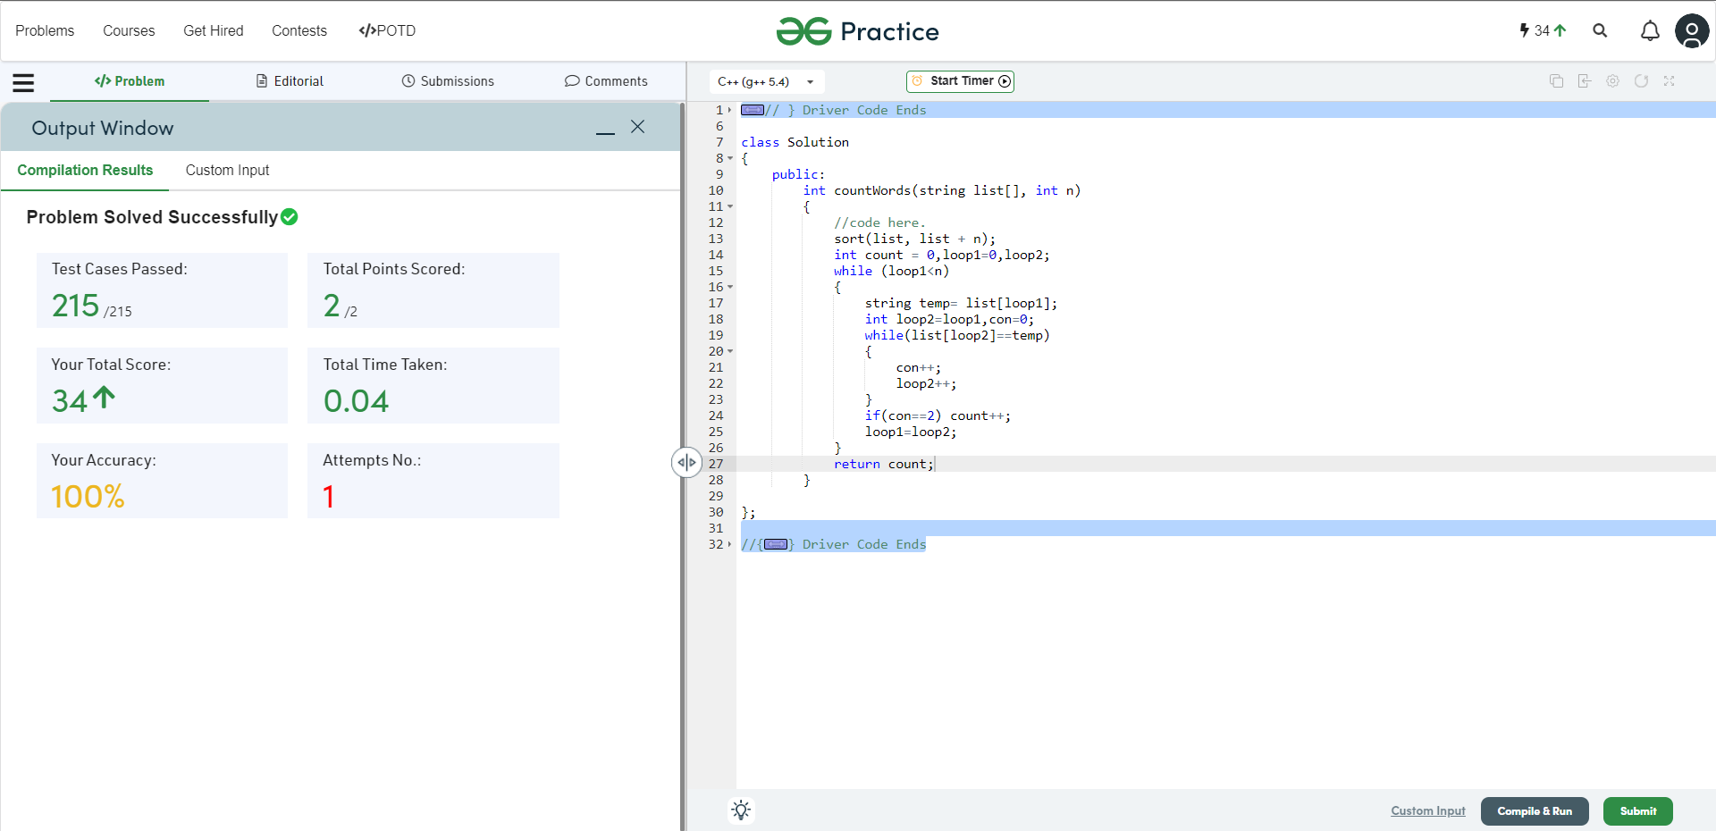

**Understanding about problem:**

* In this task I need to return number which is count of words that appear exactly twice in the list.

Note: If you can't understand the problem, feel free to contact us and we'll help you. Please don't copy and paste from anywhere.

ALL THE BEST

Team CP Club